**IDEATION PHASE**

**DEFINE THE PROBLEM STATEMENT**

|  |  |
| --- | --- |
| **Date** | 23 September 2022 |
| **Team ID** |  |
| **Project Name** | Real Time Water Quality Monitoring and Control System |

**Customer Problem Statement Template:**

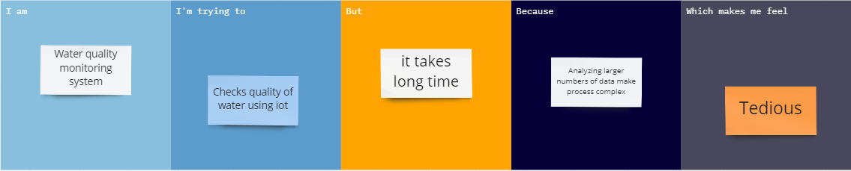

**Reference:**

<https://miro.com/app/board/uXjVPTvSbQA=/>